JOIN US FOR 3 DAYS OF LIVE MARKETS SHOWING HOW TO USE ALL OF THE ARROWS IN YOUR QUIVER TO TAKE GREAT TRADE SET UPS ON TUES, WED, AND THURS STARTING OCT. 14, AT 10:30 AM PDT
JUST CLICK ON THE DAY OF THE WEEK TO REGISTER FOR THE EVENT
TUESDAY
WEDNESDAY
THURSDAY

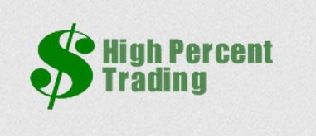 | Monday, October 13, 2014  From highpercenttrading.com‎

LEARN HOW TO TRADE USING ALL OF THE ARROWS IN YOUR QUIVER

WE WILL SHOW NUMEROUS LIVE MARKETS TRADE SET UPS ON TUES, WED AND THURS STARTING OCTOBER. 14, AT 10:30 AM PDT
JUST CLICK ON THE DAY OF THE WEEK TO REGISTER FOR THE EVENT

TUESDAY
WEDNESDAY
THURSDAY

WE WILL SHOW HOW TO TRADE ALGO BANDS WITH THE QUARTERBACK INDICATOR
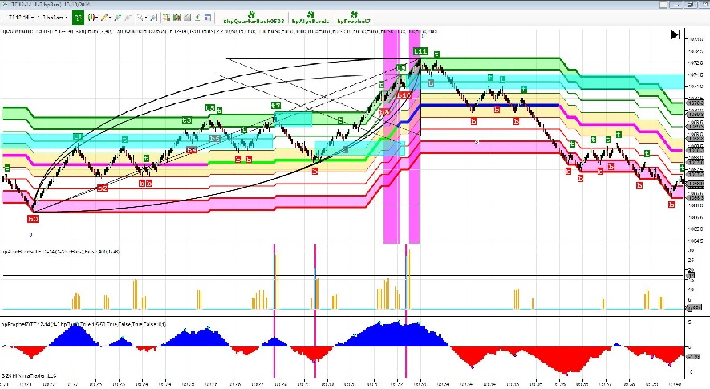

WE WILL SHOW THE COMBINED USE OF SOME OF THE MORE POPULAR OF THE 23 INDICATORS IN THE HIGH PERCENT PACK

Join us as we cover many markets in real time showing the trade setups, entries and suggested exits as they occur in real time using many of the indicators contained within the High Percent Trading Packages. We will show how to easily enter trades using a combination of the Algo bands Indicator and the Quarterback Indicator which uses a combination of Elliot Wave and Gann Analysis to pipoint moves , entries and exits down to the last tick with amazing accuracy and consistency specifically designed for Day trading purposes.
We will integrate several other of the Indicators found within the High Percent Trading Package, including the use of the Prophet indicator to help determine the trigger entry point and the Outer Limits Algos to help determine high probability trade set ups. We will demonstrate the use the new Quarterback Indicator which uses Advanced Elliot and Gann Analysis and the use of the Milkey Way indicator which is based upon special Geometric Ratios. Please Click here to view a short Video showing the combined use of the Algo Bands and the Quarterback Indicator in action together.

We will also show the new Prototype of the Algo Bands Indicator which is the precursor to a fully automated trade entry and exit system using the Algo Bands Indicator. It is fully functional and is producing some great trade results! Since each market trades differently on each day of the week the Algo Bands analyzes each market day by day and produces approximately 12 different trade setups each trading session for the market you are interested in trading. The webinar will be interactive among all the attendees present and all questions asked will be answered, including the methodology and use of the new Algo Bands Indicator.

The trade setups can even be Entered and Managed Automatically using the Multi Trader Automated Trade Platform. We will demonstrate the new Prototype of the Second Generation Multi Trader Trade Platform which will allow the user to select the 2/20 or 3/48 Dynamic Trend Indicator to place trades. We will attempt to answer all questions that you may have regarding these indicators and Strategies will be answered, and in depth technical demonstrations of the nuts and bolts of them will be discussed in great length.

WE WILL ALSO COVER MANY EXAMPLES OF TRADE SETUPS ON MANY OTHER MARKETS INCLUDING SHOWING THE DAILY AUTO FIB CLUSTERS
Time permitting,we will cover retrace trades using the Right Edge Indicator, the Dynamic Trends, the Prophet and other combinations of indicators to enter the trades. These trade set ups even allow the user to automatically enter and exit trades on the Trade Platform by activating the Multi Trader Platform which is included with the High Percent Trading Packages. This way you will never again miss a trade set up and entry once you activate the platform since the trade will automatically be entered and managed when the reversal bar signals an entry after the appropriate set up on the chart. Once the trade is entered it will be automatically managed with initial and trailing stops and profit target exits.

,

Just a reminder, a Free trial of some of these amazing new indicators will be offered to anyone in attendance who has not had the trial before.

We are also very excited to announce that High Percent Trading has been invited to be a guest speaker at the Power Trading Network Event sponsored by Ninja Trader and SharkIndicators. The Power Trading Network is comprised of some of the industry’s most trusted and sought after trade rooms, coaches, indicator vendors, and software providers. High Percent Trading is scheduled to present at 1:30 PDT ( 4:30 EDT) on Thursday, October 16, 2014. Please Click here to register for the Event if you wish to Attend or to garner further information about this great Event.

Also as a reminder all of the Webinars currently scheduled for the week are now posted on the High Percent Trading Website. Please Click Here if you wish to go to the site to view them all, as well as tons of other great information, links to free trails, and links to the Standard and Pro Packages if you wish to become a member.

You're invited to attend these timely and unique Live markets Webinars and we hope you will be in attendance so please try not to miss it. Your input and questions will be greatly encouraged and appreciated. Please try not to miss them!

JOIN US FOR 3 DAYS OF LIVE MARKETS SHOWING HOW TO USE ALL OF THE ARROWS IN YOUR QUIVER TO TAKE GREAT TRADE SET UPS ON TUES, WED, AND THURS STARTING OCT. 14, AT 10:30 AM PDT

JUST CLICK ON THE DAY OF THE WEEK TO REGISTER FOR THE EVENTS

TUESDAY
WEDNESDAY
THURSDAY

Come visit us and learn more on our website highpercenttrading.com‎

